FTP
User Guide Unrated CDRs

Table of Contents
1 Document history 2
2 Introduction 4
3 FTP 4
3.1 Overview 4
3.2 Directory structure 4
3.3 CDR Files 6
3.4 Consolidated CDR Request 7
3.5 Consolidated CDR Download 9
3.6 Consolidated CDR File Format: 9
3.7 Maintenance and support 10
4 Glossary 11
5 Appendix A: CDR File 13
5.1 CDR File Format 13
5.1.1 Character Coding 13
5.1.2 File Mark-up Coding 13
5.1.3 Compression/Decompression Algorithms 13
5.1.4 File Name 13
5.2 Call Detail Record Format 14
5.3 Sample Call Detail Record 17
Appendix B: Colt Error codes 19
Appendix C: Country Codes 20

Document history
Version | Issue Date | Description of change from previous version
1.0 | 16-Nov-11 | First version of user manual
1.1 | 20-Jan-12 | Updated with new consolidated CDR feature
1.2 | 05-Nov-12 | Updated with details of Contact Centre Services
1.3 | 21-Nov-12 | Updated with details of Number Hosting Services
1.4 | 28-May-13 | Updated with further details for Contact Centre Services
1.5 | 05-Sept-13 | Update with further details for International Contact Centre
1.6 | 23-July-15 | Updated to reflect the UK & France Regulatory impacts on the unrated CDRs for calls to non-geographic numbers.
1.7 | 10-Aug-15 | We have extended the SIP Trunking service to the following countries: Czech Republic & Luxembourg and unrated CDRs are now available for you to download from Cocom Web Manager & FTP. The country codes now include CZ & LU as seen in appendix C
1.8 | 27-Oct-15 | Sample CDRs refreshed.
1.9 | 20-Jan-16 | Updated to Reflect the new COLT logo and Sample CDRs refreshed.
2.0 | 04-Mar-17 | Replaced VoIP Access with SIP Trunking, updated to reflect change in the notification period for planned maintenance work in section 3.7,addition of new countries in Appendix C
2.1 | 08-Mar-17 | We now support an enhanced ISDN service over SIP, which is a next generation version of Voice Line. Unrated CDRs for Voice Line (v) will be available under “IP Voice Line” in Cocom.
2.2 | 26-Apr-17 | Additional information provided for Voice Line (v) and SIP Trunking to the CDR contents
2.3 | 06-Mar-18 | Additional information for Global IN to the CDR contents
2.4 | 04-Feb-22 | Updated to reflect CDRs being migrated from Cocom Web Manager to Colt Online and general updates.

Introduction
Colt Technology services (Colt) has provided you with an electronic interface for the daily transfer of call detail records (CDR).This system is referred to as Cocom.
FTP
This interface allows you to retrieve the CDRs resulting from your end-customers’ traffic within the Colt network.
This document describes the process of how to successfully retrieve CDR files from Colt.

FTP
  - Overview
The Cocom server currently supports FTP access to dedicated and protected directories that have been created specifically for your business. Additionally access via API and a graphical user interface / portal is available.
Access to the server is via a dedicated VPN client, provided by Colt. This method is detailed in separate documents accompanying this guide. Colt will assign a temporary IP address on successful access that will remain valid and available only for the duration of your connection to the service.
When you connect with Colt, you will be prompted to enter two User IDs and passwords; the first to gain access to Colt’s customer network, and the second to gain access to your home directory on the Cocom server.
After you have successfully gained access to the server you will be connected to your home directory. Your home directory has been created specifically for you and can only be accessed using the User ID provided to you by Colt.
To use the service you will need to integrate these processes and file interface into your own IT environment. For a stand-alone operation you can use a standard FTP client. Any of the commonly available FTP clients should be satisfactory, for example ReflectionFTP.

  - Directory structure
Files within this directory are protected from access by others in a secure environment. The key directories in your home directory on the Cocom Server are shown in the diagram below.
From here you can download your unrated CDRs for all your Colt Voice & VoIP products across one or more Colt countries.
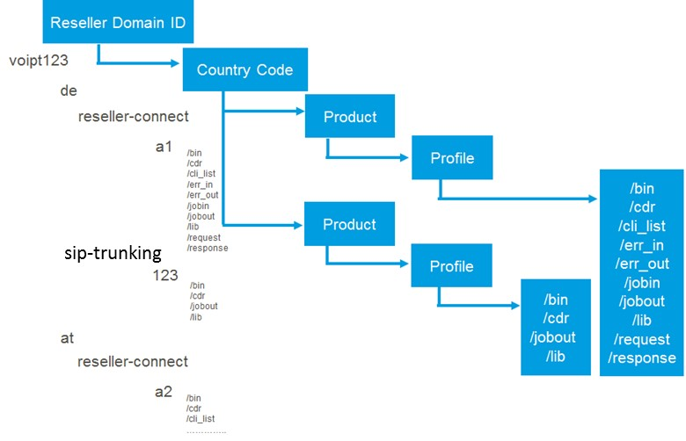
Diagram notes

- Note lower case values above
- Reseller Domain ID is an auto-generated ID, a combination of your company name & random digits, minimum length of 5 and max length of 8
- Country code in ISO 2 character format, note gb is used
- The product will be one of the following - all lower case:-
- reseller-connect
- sip-trunking
- voice-line
- ip-voice-line
- in-for-resellers
- geographic-number-hosting
- in-number-hosting
- The profile is up to 5 alphanumerics and is the account or service profile

Account profiles are set up based on your billing account (BCN), whereas service profiles are set up per service instance. Account profiles will apply to products such as SIP Trunking and Voice Line, and service profiles will apply to Reseller Connect.
If you have more than one product on the same billing account (BCN), e.g. SIP Trunking & Voice Line, then they will have the same account profile.
Service profiles apply for the products Reseller Connect, Geographic Number Hosting and IN Number Hosting (unrated CDRs). Service profiles enable Colt to continue to support multiple Reseller service profiles being billed on the same Colt billing account (BCN) and provide unrated CDRs per service profile to Cocom.
Your account or service profiles will conform to the new standard of up to 5 alphanumerics.
The unrated CDR files will be generated in separate files by profile and made available under each product as per the FTP folder structure above.
The files provided by Colt such as CDR files, and response files are available in separate sub-directories in a standard format (detailed in the Appendices to this Guide):
/jobout | the directory where Colt will deposit job files, one for each response file
/cdr | this directory will contain your CDR files, delivered twice daily as well as any consolidated CDR files you have requested using the consolidated CDR request feature in Colt Online

  - CDR Files
Twice a day, every day of the week, Colt will deposit a file of Call Detail Records (CDR) into your /cdr directory on the server. The exception is for the Global SIP countries such as Luxembourg, the Czech Republic, Slovakia & Romania, where the unrated CDRs are delivered daily. This will contain all of the CDRs collected by the Colt network since the last file, typically each 12 hours. The CDR files are provided in a pre-defined, fixed length format. CDR file format description has been detailed in the Appendix.
CDR file naming standard
Files transferred to and from Colt are all uniquely identified and adhere to the following file format
<countrycode>_<profile>_<productidentifier>_<sequence no>_<date>.cdr.gz
Where:
- <countrycode> in ISO 2 character format
- <profile> is up to 5 alphanumerics and is the applicable profile for the product
- <productidentifier> is the product identifier (1-2 alphanumerics) – see table below
- <sequence no> is a rolling four digit sequence per <profile>_<product> combination
- <date> is YYYYMMDDHHmmss
- cdr.gz is where the file is zipped

Product Identifier | Product name
01 | Reseller Connect
00 | Voice Line
10 | SIP Trunking
11 | IP Voice Line (Voice Line (v))
12 | IN for Resellers
15 | Geographic Number Hosting
16 | IN Number Hosting

Please Note: The first CDR file will appear in FTP after the first call has been made.

  - Consolidated CDR Request
This feature enables you to place a request for a consolidated CDR file through Colt Online. Up to 90 days of CDRs can be requested, e.g. a consolidated file of a week’s worth of CDRs and these files will be delivered to both Colt Online & FTP.
In Colt Online, click on “Download Unrated CDRs” under the “Billing” header and on the right side of the screen:
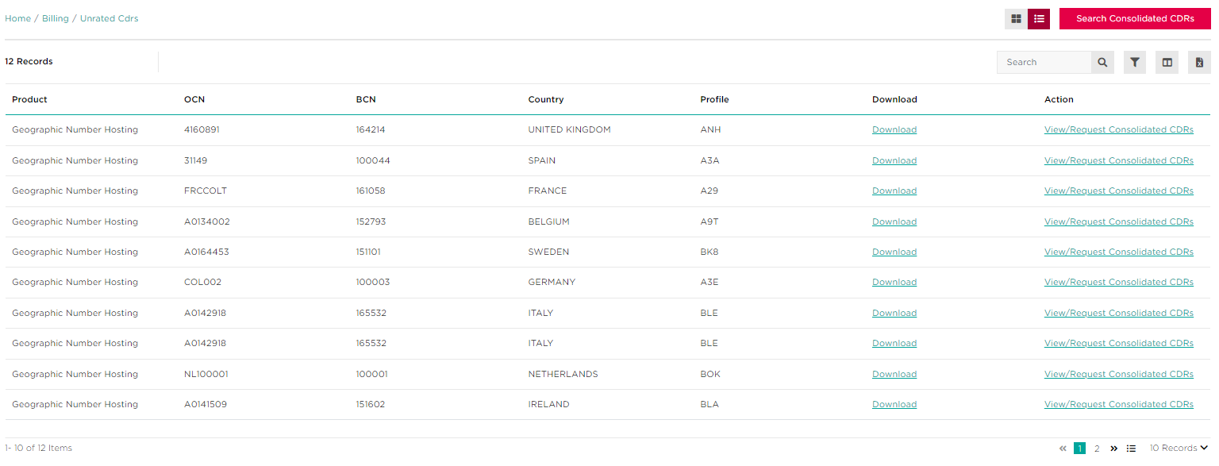
- Select either “View/Request Consolidated CDRs” if you see the order you want to request a consolidated CDR file for, or “Search Consolidated CDRs”.
1
1

- After clicking “Search Consolidated CDRs”, you will then have the ability to request new consolidated CDRs by using the button in the top right, as well as being able to search an order ID in the top left to view consolidated CDRs for a particular order
2
2
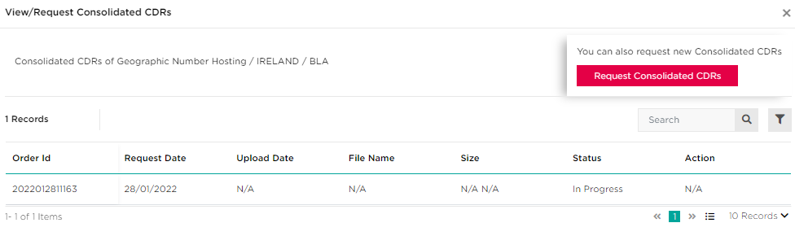
If you clicked “View/Request Consolidated CDRs”, then you will be presented with a similar screen, but will also be able to view the consolidated CDR for the order you clicked through.

- Select the relevant product, country, profile and preferred date range for your request then click “Submit” to continue
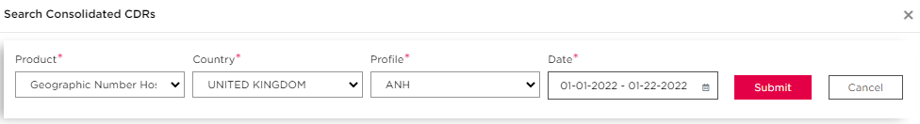

Your consolidated CDR request will then be processed, and you will be presented with an order ID for this request in the bottom left corner of your screen.

Please keep a record of this order id so you can quickly search for your consolidated CDR using the search functionality

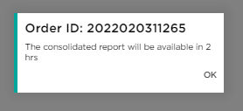

Please Note: When you wish to consolidate unrated CDRs, these CDRs will be delivered to Colt Online & FTP in a compressed/zipped format. If your twice daily CDR files are already over 5MB in size, then please allow time to download a consolidated file from Colt Online or you may find it easier to download files greater than 5MB directly from FTP.

  - Consolidated CDR Download
Within 2 hours the consolidated CDR file will be available in the FTP /cdr file under the product & profile which you used in your request.
The consolidated CDR file will be available to download from the Cocom server for 5 days, after that the file will be removed and you will need to submit a new request (if you have not downloaded it).

  - Consolidated CDR File Format:
All Consolidated CDR files delivered to Colt Online and FTP have a filename in the following format:-
<profile><transactionID>.cdr.zip.

Where:
- <profile> is up to 5 alphanumeric and is the applicable profile for the product
- <transactionID> is the combination of date and unique number, this can be used in Colt Online to search for Consolidated CDR
- .cdr is the extension
- .zip is where the file is zipped
Example: AM220120110182.cdr.zip

The content of the consolidated CDR file is the same as the standard twice daily delivered CDRs, as described in Appendix A.

  - Maintenance and support
The Cocom B2B Gateway Server is available 24 x 7 x 365.
Should we need to temporarily suspend access to the server, for planned maintenance, you will be notified at least 10 days in advance and be told how long it will be suspended for. Generally, this is an unusual occurrence (approximately once a month) and service interruptions are brief.
Customer Service is available during normal office hours, from Monday to Friday except during Public Holidays.

Glossary
Term | Description
B2B | Business to Business:  typically takes the form of automated processes between trading partners and is performed in much higher volumes than business-to-consumer (B2C) applications.
CDR | Call Detail Record. A record that contains the details of a call made on the Colt network. Normally used for end-customer billing purposes. In Cocom this will be unrated, i.e. contains no charges but indicates the service used during the call and the tariff band(s) that apply. If the CDR is rated, then it will include the charge due for the call. Rated CDRs can be found in Colt Online alongside your Colt invoice, in a monthly or quarterly file.
CLI | Calling Line Identifier. A term used within Colt to mean an end-customer telephone number such as a Directory number.
Cocom | Colt Communications server. The FTP server and internal applications that provide a file level interface allowing Resellers to download CDRs.
CSV | Character Separated Values or  Comma Separated Values:  file format is a tabular data format that has fields separated by the comma character and quoted by the double quote character. If a field’s value contains a double quote character it is escaped with a pair of double quote characters.  The CSV file format does not require a specific character encoding, byte order or line terminator format.
FTP | File Transfer Protocol:  is a software standard for transferring computer files between machines with widely different operating systems. It belongs to the application layer of the Internet protocol suite.
GB | Great Britain
HTML | Hyper Text Mark up Language:  is a markup language designed for the creation of web pages and other information viewable in a browser. HTML is used to structure information –denoting certain text as headings, paragraphs, lists etc.- and can be used to define the semantics of a document
HTTP | HyperText Transfer Protocol):  is the primary method used to convey information on the World Wide Web. The original purpose was to provide a way to publish and receive HTML pages. The default TCP port of HTTP is 80.
HTTPS | HyperText Transfer Protocol Secure:  is the secure version of HTTP, the communication protocol of the World Wide Web. It was invented by Netscape Communications Corporation to provide authentication and encrypted communication and is used in electronic commerce.  Instead of using plain text socket communication, HTTPS encrypts the session data using either a version of the SSL (Secure Socket Layer) protocol or the TLS (Transport Layer Security) protocol, thus ensuring reasonable protection from eavesdroppers, and man in the middle attacks. The default TCP port of HTTPS is 443.
SMTP | Simple Mail Transfer Protocol:  is a relatively simple, text-based protocol, where one or more recipients of a message are specified (and in most cases verified to exist). The message text is transferred to the specified recipients.  SMTP uses TCP port 25.
URL | Uniform Resource Locator:  or Web address, is a standardized address name layout for resources (such as documents or images) on the Internet (or elsewhere). First created by Tim Berners-Lee for use on the World Wide Web, the currently used forms are detailed by Internet standard RFC 1738.
WWW | World Wide Web:  is an information space in which the items of interest, referred to as resources, are identified by global identifiers called Uniform Resource Identifiers (URLs). The term is often mistakenly used as a synonym for the Internet, but the Web is actually a service that operates over the Internet.
XML | eXtensible Mark up Language:  is a W3C-recommended general-purpose markup language for creating special-purpose markup languages. It is a simplified subset of SGML, capable of describing many different kinds of data. Its primary purpose is to facilitate the sharing of data across different systems, particularly systems connected via the Internet.

Appendix A: CDR File
The CDR file contains only CDR records in a fixed length format. A CDR file is made available twice per day – once in the morning and once in the afternoon. The files are delivered at approximately 9AM and 5PM CET.
- The 9 AM CET file contains calls from 4PM CET the previous day until 8AM CET on the current day
- The 5 PM CET file contains calls from 8AM CET to 4PM CET on the current day
Please note that CDR files are delivered to your directory 7 days a week and will vary in size depending on the level of traffic that your customers generate.
Please note the exception is for the Global SIP countries such as Luxembourg, the Czech Republic, Slovakia & Romania, where the unrated CDRs are delivered daily at approximately 9 AM CET.

  - CDR File Format
    - Character Coding
ASCII
    - File Mark-up Coding
- No structured Mark-Up used
- Fixed length records
- Fixed length fields, space filled
    - Compression/Decompression Algorithms
CDR files are delivered in Zip format (Unix Gzip, MS Windows Zip). However, Colt recognizes that this can be difficult for certain companies to receive and the CDR files can be delivered in plain text if required. Please notify the Colt Customer Services if you need the CDR files to be delivered as plain text (Uncompressed) files.
    - File Name
All unrated CDR files delivered to Colt Online and FTP have a filename in the following format:-
<countrycode>_<profile>_<productidentifier>_<sequence no>_<date>.cdr.gz
Where:
- <countrycode> in ISO 2 character format
- <profile> is up to 5 alphanumerics and is the applicable profile for the product
- <productidentifier> is the product identifier (1-2 alphanumerics) – see table below
- <sequence no> is a rolling four digit sequence per <profile>_<product> combination
- <date> is YYYYMMDDHHmmss
- .cdr is the extension
- .gz is where the file is zipped

Product Identifier | Product name
01 | Reseller Connect
00 | Voice Line
10 | SIP Trunking
11 | IP Voice Line (Voice Line (v))
12 | IN for Resellers
15 | Geographic Number Hosting
16 | IN Number Hosting

Example: DE_ABC_01_0001_20101208090122.cdr.gz
  - Call Detail Record Format
A standard format for unrated CDRs applies to our reseller and wholesale product portfolio.. This standard CDR format is harmonised across all Colt countries and applies to existing and new products going forward in Colt Online.
The data lines are 229 bytes in length and organised as:
Ref | Name | Bytes/  Length | Position | Alpha/  Numeric | Format & Description
1 | Origin | 20 | 1 | N | Originating CLI with leading 0. Filler spaces must be added to fill in the spaces designated for a field. In the case of IN, the last 4 digits are replaced with ‘x’.  In the case of LU ,CZ,SK & RO for SIP Trunking, the Originating CLI starts with the country code  In the case of Global IN for Resellers ordered through the UK, the caller’s number will be in the international format, starting with 00 + the country code + the number (omitting the leading zero) e.g. caller calling from a mobile in Romania: 004074582xxxx
2 | Destination (Terminating) | 20 | 21 | N | Destination 0 = Domestic and National, Destination 00 = International  In the case of LU ,CZ,SK & RO for SIP Trunking, the destination starts with the country code
3 | Product Type | 2 | 41 | N | ‘01’=Indirect Service  ‘00’ = Direct Service  '04' = Direct Service  ’06‘=NH Geo Premium  ‘07’=NH Geo Wholesale  '08'=NH Geo Retail  '09'=NH Geo Incoming  '10'=NH IN Incoming  '79' = SIP Trunking  ‘80’ = IP Voice Line (Voice Line (v))
4 | Date | 8 | 43 | N | YYYYMMDD
5 | Time | 8 | 51 | N | HHMMSSss . Time duration is broken up into tenths of a second. Fractions of a second will be ignored.
6 | Duration | 8 | 59 | N | Duration of the call to the nearest 1/10th of a second SSSSSSSs
7 | Continuation | 1 | 67 | N | ‘0’, ‘1’, ‘2’, ‘3’ or ‘5’ – normally a 0. To be used only if calls are greater than 6 hours
8 | Switch ID | 25 | 68 | N | Unique switch identifier
9 | Trunk incoming | 25 | 93 | N | Internal use only
10 | Trunk outgoing | 25 | 118 | N | Internal use only
11 | Account Code | 20 | 143 | A | Not in use
12 | Pulses in | 6 | 163 | N | Not in use
13 | Pulses generated | 6 | 169 | N | Not in use
14 | Pulses sent | 6 | 175 | A | In use for all IN, Voice & VoIP services in UK & France: Charge Band defined by Regulator(Ofcom UK/Arcep FR) for calls to non-geographic numbers. If no Charge Band is available, the value is 000000 or blank.
15 | Service Indicator | 4 | 181 | N | 0000 for standard calls, 0001 for ISDN calls
16 | Charged (C-Num) | 20 | 185 | N | Trunk ID shown here for IP Voice Line (Voice Line (v)) and for SIP Trunking  In use for IN services – the number to which the IN service number is translated.  In the case of Global IN for Resellers ordered through the UK, this number will be in the international format, starting with 00 + the country code + the number (omitting the leading zero)
17 | Dialled (D-Num) | 20 | 205 | N | In use for IN services (IN service number)  In the case of Global IN for Resellers ordered through the UK, the IN service number will be in the international format, starting with 00 + the country code + the number (omitting the leading zero) e.g. Romania freephone number: 0040800890123
18 | Carrier | 3 | 225 | A | The Reseller profile of up to 3 alphanumerics
19 | End of Record | 1 | 228 | A | Value of zero is shown
20 | Line Feed | 1 | 229 | ASCII Control Character | Line Feed (ASCII Control Character not visible in plain text editors

Please note: There is an ASCII Control Character (Line Feed, HEX 0A) after the last field 19 “End of record”. This Control character generates a new line for the next CDR and shows that the actual CDR ends. Normally you can ignore this control character except you use a HEX-Editor to process your CDRs.

Please note: In Germany, the header and trailer records will no longer appear in the unrated CDR file. They will appear as a single file in the “jobout” FTP-folder

  - Sample Call Detail Record
Sample CDRs for Reseller Connect:-
06960621234 069566061234012011011911481500000000401 00067 6960621234 0000 069566061234AAX0
06960621234 017622211234012011011911514400000008401 00067 6960621234 0000 017622211234AAX0

Sample CDRs for Reseller Connect (UK):-
02085021011 08708989300012015082110382740000003510 01000 3066 4013 000000000000 SC0060000 8530 8531S
02089537800 08435047176012015082110351910000078520 01000 4123 4139 000000000000 SC0080000 8530 8531S

Sample unrated CDRs for Voice Line:-
06971041234 0368751234002011093007235400000007301 00063 OF3XBN33687512340 0000010000010000 0368751234 SV0
06971041234 038203731234002011093007225600000013201 00063 OF3XBN33855523484 0000010000010000 038203731234 SV0
06971041234 066311234002011093007250000000001101 00063 OF3EZLA663121234 0000010000010000 066311234 SV0

Sample unrated CDRs for Voice Line (FR):-
0982406525 0841118663002015082009134390000074070 03300 1088 1062 000000000000 A0050010 0033899108018PBW0 PBW2S
0494270512 0494107021002015082011415520000000540 03302 1503 1503 000000000000 A0050010 0033826106714PAC0 PAC2S

Sample unrated CDRs for SIP Trunking:-
038422001234 081010251234792011060314221108000000000 ZHA CXVIE013038422001234 0000 ABC0
038422001234 0517661234792011060314222708000022440 ZHA CXVIE013038422001234 0000 ABC0
0732388824321 0732771234792011060314261409000013790 ZHA CXVIE0130732388824321 0000 ABC0
0158031234 00351913231234792011060314323700000000210 ZHA CXMAD0130158031234 0000 ABC0

Sample unrated CDRs for SIP Trunking (CZ, FI, JP, LU, NO, RO & SK):-
352206099 442033535570792015091610405600 170 0000 ALB0
420296180311 442033535475792015100911120200 550 0000 AAX0
40312200237 40753086507792015070215113800 1480 0000 BKD0
421232335698 390321393652792015092110045300 90 0000 BKE0

Sample unrated CDRs for IN for Resellers (Freephone & shared cost):-
0129356xxxx 08003581234002011101923483510000008300 01001 3059 0129356xxxx 0000000000000000000000 01618361234 08003581234ADC0
0773777xxxx 08003581234002011101923455270000068380 01001 2702 0773777xxxx 0000000000000000000000 01618361234 08003581234ADC0
0755747xxxx 08003581234002011101923580620000008090 01001 2042 0755747xxxx 0000000000000000000000 01618361234 08003581234ADC0

Sample unrated CDRs for Geographic Number Hosting:-
0307870098 0230333517082012110610363380000005050 MIA SNCB0103 CXMIT0130307870098 0000 AJC0
0230333517 0307870098092012110610401400000002570 MIA CXMIT013 SNCB01010230333517 0000 AJC0

Sample unrated CDRs for IN Number Hosting:-
0230329xxx 800909395002012102610530410000000730 00225 10270230329xxx 0000000000000000000010 3483954697 39800909395AJB0
Sample unrated CDR for Global IN for reseller (CA, CZ, FI, HK, JP, NO, RO & US):-
004074582xxxx 0040800890020002018032308352100000000240 00000 004074582xxxx 0000 00 0040800890020DMP0
004074582xxxx 0040800890020002018032308394500000000240 00000 004074582xxxx 0000 00 0040800890020DMP0

Please Note: The first CDR file will appear in Colt Online after the first call has been made.

Appendix B: Colt Error codes
Message Code | Message Type | Message Description | Explanation
0 | B2BGateway | Success Message/OK
-1 | B2BGateway | Unable to process your request [additional explanation] | Validation Failed, e.g. Infrastructure Error from Cocom, missing request file, wrong characters
0 | Cocom | OK – Success
99 | Cocom | Cannot process your request! Please contact customer service support! | No connection between B2B Gateway and Cocom
Table – B2B Gateway error Codes

Appendix C: Country Codes
Country Code | Country Name
AT | Austria
BE | Belgium
DE | Germany
ES | Spain
FR | France
GB | Great Britain
IE | Ireland
IT | Italy
NL | Netherlands
SE | Sweden
DK | Denmark
PT | Portugal
CH | Switzerland
LU* | Luxembourg
CZ* | Czech Republic
SK* | Slovakia
RO* | Romania
*Unrated CDRs for e.g. LU, CZ, SK & RO are available for the SIP Trunking service only.

